**How To Run Chapter 5 Example Code**

**IppPrintRequest**

1. Navigate to: \code\CsIppRequests\IppPrintRequest\bin\Release
2. Open a Console Window.
3. Usage: IppPrintRequest <full path to print job attributes file>
4. An example job attributes file can be found in the \code\CsIppRequests\IppPrintRequest folder. This is printer-specific (HP M528 printer) and will need to be altered for your IPP printer.
5. Example: IppPrintRequest.exe" C:\temp\JobAttributes.txt
6. The utility will prompt you for any information it needs, for example, it will ask

Would you like to validate, create, cancel, senddoc, or printjob?

Note: If you run this in the debugger, set the Startup Project to IppPrintRequest.

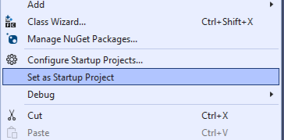

1. The DLL is created in the CsIppRequestLib Project which is in the same Solution.